|  |  |
| --- | --- |
| How to | D:\projecten\1210326 MDBA ROWS (local, See N)\C. Report - advise\Workshops\2015-02 workshop 3 UAT, end user training\Screenshots\DELTARES_ENABLING_RGB.pngSource - Prepare Precipitation data for Source RO |
| Description | D:\Software_delft-fews (local, See P)\Marketing\Icons (FEWS_logo_icon)\Delf-FEWS-256x256.pngSelect short term forecast and combine with observed and zeros |
| Comments | Please be aware that the screenshots may deviate slightly from the application |
| version | 2016-01 |

Precipitation data are location based time series, created by merging 3 types of data:

* Observations (OPO)
* Short term forecast, with user defined source selection in modifier display from:
  + ACCESS-G
  + ACCESS-R
  + ADFD
  + PME
  + None
* Long term forecast: no rain

To select the short term forecast:

1. Complete the OPO observed Flow for all locations (elsewhere in Workflows display)
2. Run the workflow, to process the gridded rainfall products to the Source locations
3. Select the source for the gridded rainfall in the Modifiers display
4. *Apply* and *Re-run*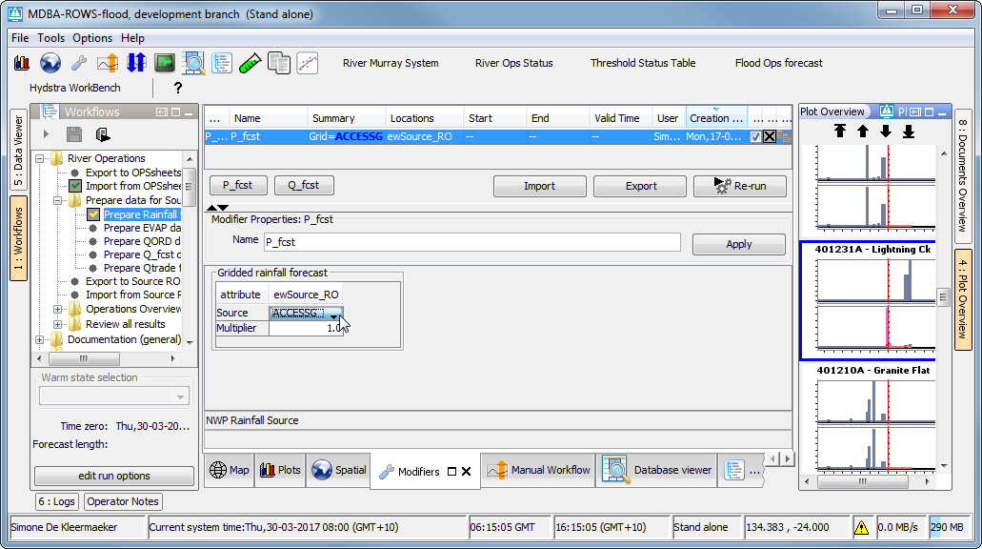

3

2

1

4